**DECIMAL TO HEXADECIMAL CONVERSION:**

**EXP NO:28**

**AIM:**To write a C program to implement decimal to hexadecimal conversion.

**APPARATUS:** DEV C++

**ALGORITHM:**

1)Divide the number by 16.

2)Get the integer quotient for the next iteration.

3)Get the remainder for the hex digit.

4)Repeat the steps until the quotient is equal to 0.

**PROGRAM:**#include<stdio.h>

int main ()

{

long decimal num, quotient, remainder;

int i, j = 0;

char hexadecimalnum[100];

printf ("Enter decimal number: ");

scanf("%ld", &decimalnum);

quotient = decimal num;

while (quotient! = 0)

{

remainder = quotient % 16;

if (remainder < 10)

hexadecimalnum[j++] = 48 + remainder;

else

hexadecimalnum[j++] = 55 + remainder;

quotient = quotient / 16;

}

for (i = j; i >= 0; i--)

printf ("%c", hexadecimalnum[i]);

return 0;

}

**INPUT:**

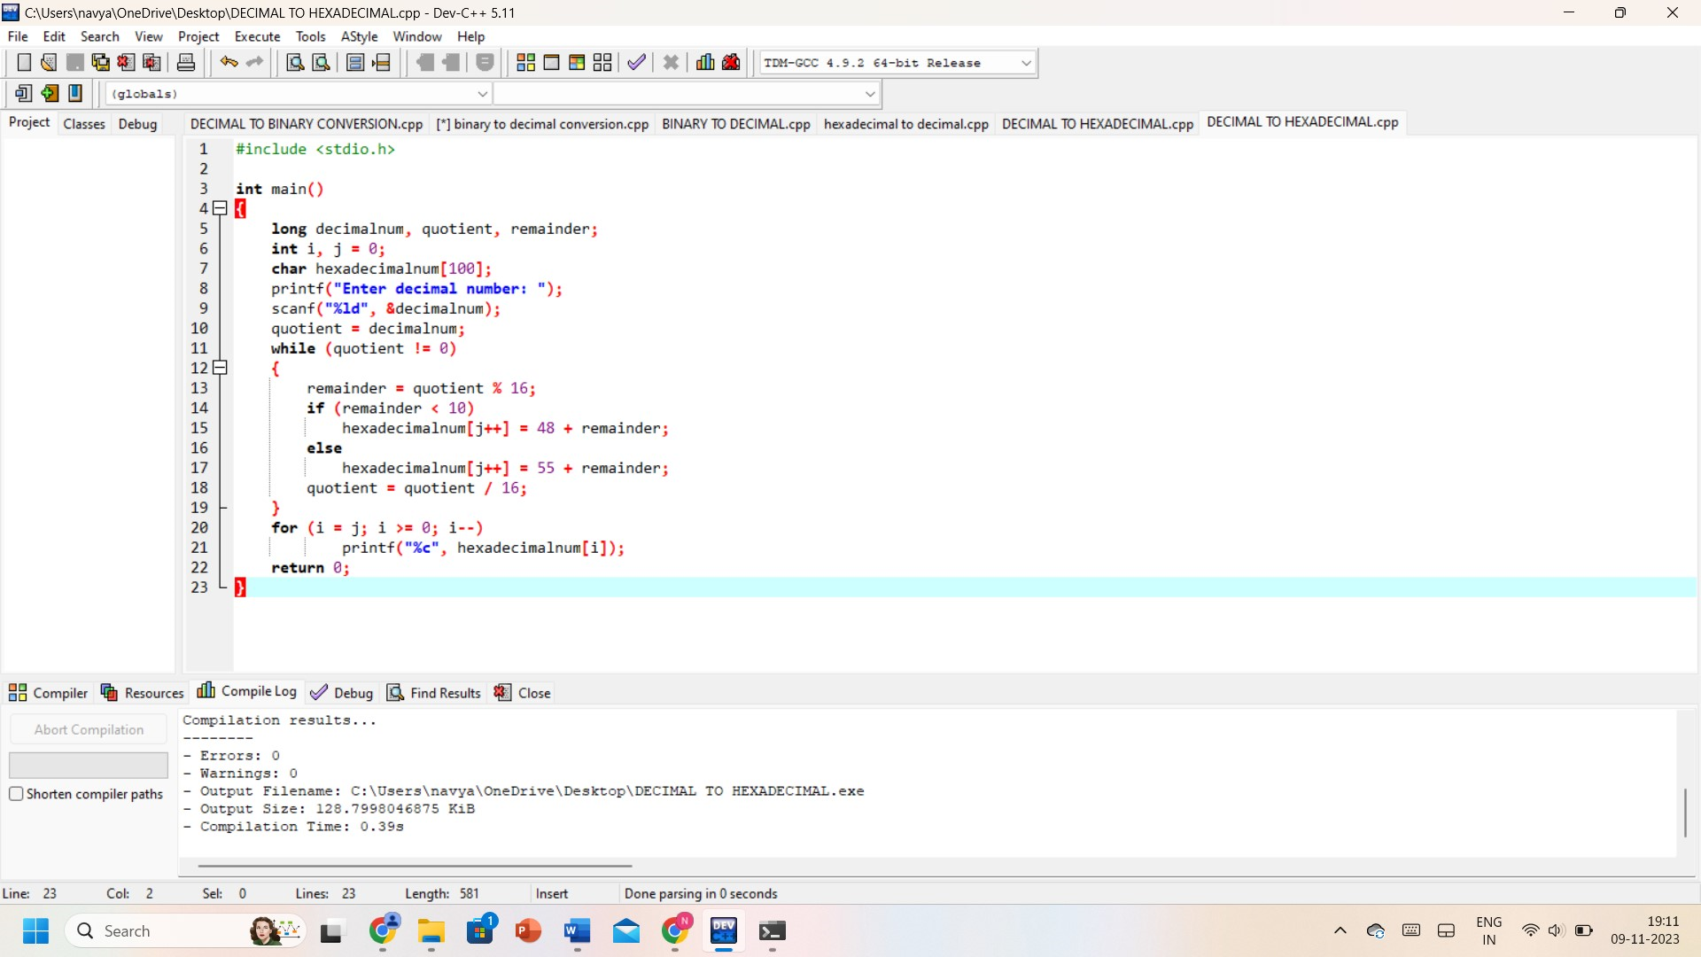

**OUTPUT:**

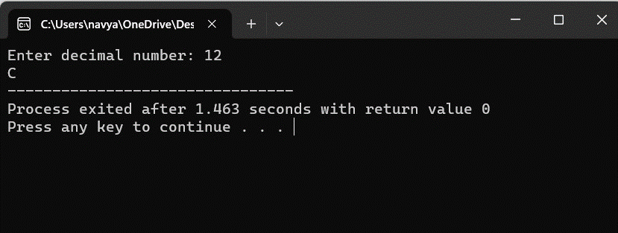

**RESULT:** Thus, the program was executed successfully using DevC++.